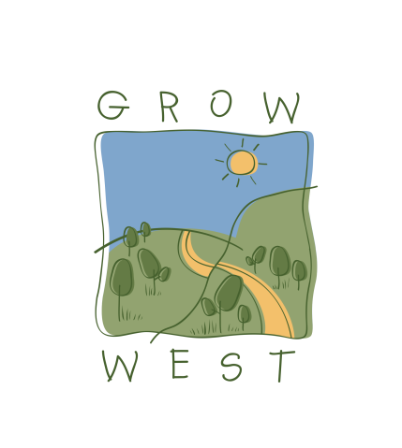
Snapshot
2011-12

Funding
During 2011/12, the PPWCMA secured:
- $477,235 to coordinate and undertake projects in the Grow West area, including:
  - $413,235 from the Victorian Government’s Vision for Werribee Plains initiative for the Pentland Hills Landcare group to work on biolinks along the Myrniong and Korkuperrimul Creeks;
  - the Rowsley Landcare Group to work on a biolink along the Whitehorse Creek; and
  - an ongoing rabbit control study at Ingliston.
- $50,000 from partner organisations including te Moorabool Shire Council, Melbourne Water and Southern Rural Water; and
- $14,000 from Computershare e-Tree via Landcare Australia Limited for the annual Grow West Community Planting Day.
- A proposal to build a biolink between the Brisbane Ranges and Werribee Gorge was successful and will be funded by $1,393,500 from the Australian Government’s Biodiversity Fund. This funding commences in 2012/13 and carries over three years.

Achievements in 2011/12
During 2011/12, Grow West supported site preparation works, revegetation, weed treatment and rabbit control activities. These included:
- Revegetation of seven hectares with 6,500 seedlings at Yaloak Estate in the Rowsley Valley in partnership with the Victorian National Parks Association and Moorabool Shire Council, making a substantial contribution to a biolink with the Brisbane Ranges National Park
- The second stage of a rabbit impact trial held in collaboration with Melbourne Water, the Department of Sustainability and Environment, the Department of Primary Industries, Parks Victoria and Moorabool Shire Council to rehabilitate 110 hectares of land and 12 kilometres of waterways at Ingliston;
- Collaboration with Pentland Hills Landcare Group and Melbourne Water to begin the rehabilitation of 130 hectares of land and 13 kilometres of waterways along the Myrniong and Korkuperrimul Creeks; and
- 110 hectares of rabbit control works along the new Western Freeway on behalf of VicRoads between Melton and Bacchus Marsh.

Marketing Activities
A range of marketing activities were undertaken to build support for Grow West in the local community and enable the delivery of onground works. Events and activities held in 2011/12 included:
- The annual Grow West Community Planting Day was held at Yaloak Estate and involved over 150 volunteers planting 6,500 indigenous seedlings;
- Promotion of Grow West at the Pentland Hills Landholder Expo and the Moorabool Shire Council Volunteer Exposition;
- Sponsorship of the Grow West Art Prize in the Bacchus Marsh Rotary Art Show; and
- A field day demonstrating successes in rabbit management on replanted and naturally regenerated land attended by over 60 people.
- The strategic direction and management of Grow West was also reviewed and a revised Grow west Implementation Plan was adopted.

