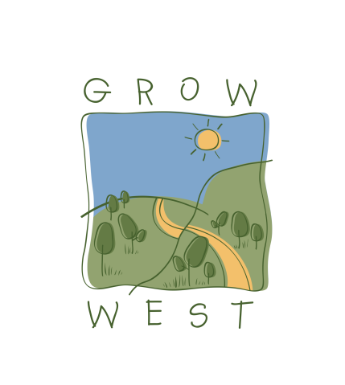
Snapshot
2010-11

Funding
During 2010/11, the PPWCMA secured revenue of $318,555 to coordinate and undertake projects in the Grow West area, comprised of:
- $199,730 from the Victorian Government’s Vision for Werribee Plains initiative;
- $55,000 from partner organisations including the Moorabool Shire Council, Melbourne Water and Southern Rural Water;
- $50,000 from ComputerShare e-Tree via Landcare Australia Limited; and
- $13,825 from corporate sponsor Red Energy.

On-ground Works
During 2010/11, Grow West supported site preparation works, revegetation, weed treatment and rabbit control activities. These included:
- Revegetation of five hectares with 5,000 seedlings at Ingliston Park near Ballan in partnership with the Victorian National Parks Association and Moorabool Shire Council that helped in creating a biolink to the Werribee River and Werribee Gorge State Park;
- Monitoring of a rabbit impact trial in collaboration with Melbourne Water, the Department of Sustainability and Environment’s Arthur Rylah Institute for Environmental Research, the Department of Primary Industries, Parks Victoria and Moorabool Shire Council that will help rehabilitation of 110 hectares of land and 12 kilometres of waterways at Ingliston; and
- Creating a collaborative project on the Myrniong Korkuperrimul Creeks with the Pentland Hills Landcare, Melbourne Water and Vision for Werribee Plains to rehabilitate over 130 hectares of land and 13 km of waterways over three years.

Events and Marketing Activities
Grow West’s events and marketing activities are designed to build support in the local community, to enable the expansion of the project to additional priority sites and enable the delivery of on-ground works. Events and activities held in 2010/11 included:
- An annual Grow West Community Planting Day held at Ingliston on a tributary to the Werribee River which saw over 130 volunteers plant 5,000 indigenous seedlings;
- Promotion at the Land Expo run by Pentland Hills Landcare, Melbourne Water Stream Frontage Program and Moorabool Shire Council. The Expo was attended by over 200 land holders and land managers;
- A field day demonstrating successes in the management of rabbit grazing on replanted and natural regeneration land, attended by over 60 people; and
- Field tours conducted in conjunction with the Melbourne Water Stream Frontage Program, Moorabool Shire Council and the Vision for Werribee Plains initiative.
- Grow West was awarded the Mayors Award in the Moorabool Shire Council’s Australia Day Community Event of the Year for the 2010 Grow West Community Planting Day.

