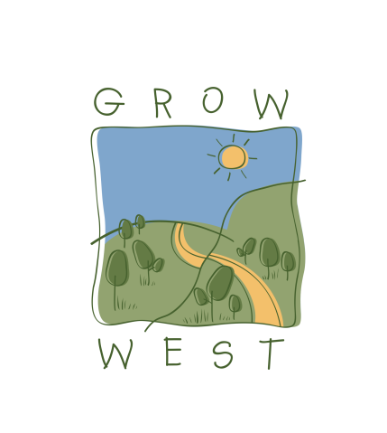
Snapshot
2009-10

Projects were undertaken including weed treatment, rabbit control activities, preparation works and revegetation primarily undertaken at six farm sites.

On ground achievements at these sites included:
- 13.5 hectares revegetated;
- 28 hectares treated for serrated tussock;
- 400 hectares treated for rabbits;
- 123 hectares treated for boxthorn.

Grow West also supported projects at specific sites within the project area, listed here:
- Rowsley Valley – controlled Serrated Tussock and Boxthorn on 12 hectares in preparation for planting of the 12 hectare site;
- Myrniong – revegetated 6.5 hectares with 6,500 seedlings at the W. James Whyte Island Reserve in partnership with Conservation Volunteers Australia and Victorian National Parks Association to advance the establishment of a ‘Myrniong Biolink’;
- Ingliston – rehabilitation program of 110 hectares along 12 kilometres of waterways developed in partnership with Melbourne Water, Department of Sustainability and Environment, Arthur Rylah Institute for Environmental Research, Department of Primary Industries, Parks Victoria and Moorabool Shire;
- Ingliston – Demonstration event to show the effect of rabbit grazing on replanted and natural regeneration in a 110 hectare large scale trial.

