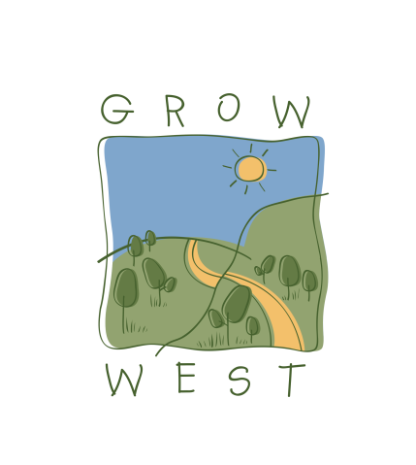
Snapshot
2008-09

Projects were undertaken at 19 farm sites including:
- 58 hectares revegetated;
- 7 hectares of remnant woodlands protected – over 1,250 metres of fencing installed;
- 56 hectares treated for serrated tussock;
- 56 hectares treated for rabbits;
- 41 hectares treated for boxthorn.

Grow West also supported projects at:
- Rowsley Valley – controlled Serrated Tussock on 38 hectares and revegetated 13 hectares of land with 12,000 seedlings;
- Myrniong – revegetated 11.5 hectares with 12,000 seedlings at the W.James Whyte Island Reserve in partnership with Conservation Volunteers Australia and Victorian National Parks Association to advance the establishment of a ‘Myrniong Biolink’;
- Ballan-Greendale Road – revegetated 5.2 hectares with 5,200 seedlings to create a biolink along a tributary to Korjamnunnip Creek.
- Funding
- Secured funding of $165,000 from Computershare e-Tree via Landcare Australia Limited
- Secured $20,000 from the Vision for Werribee Plains
- Replanted and natural regeneration in a 110 hectare large scale trial.

