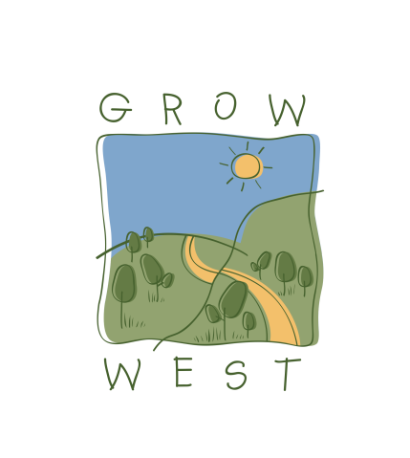
Snapshot
2007-08

In 2007-08 Grow West undertook a range of business opportunities and partnerships, including:
- Fine-tuned its business model and drafted a revised Business Plan.
- Secured $60,000 from partner organisations, $60,000 from corporate investment and $154,000 from the Australian Government’s Natural Heritage Trust.
- Ccorporate investment from Victoria Electricity and Aviva Australia Limited.
- Revegetation with locally indigenous species of approximately 80 hectares
- Establishment of approximately 70 hectares of farm forestry demonstration sites in the Rowsley Valley and Bacchus Marsh areas.
- Grow West Community Planting Day with over 100 volunteer attendees and over 3,500 trees established.
- Site of the launch of the Victorian Government’s Green Paper Land and biodiversity at a time of climate change.
- .

