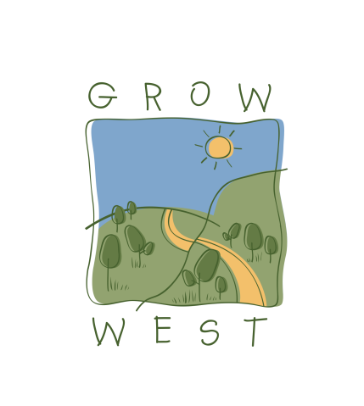
Snapshot
2006-07

Achievements include:
- Myrniong Parks Link Project – Funded under eTree and Norman Wettenhall – 25 hectare bordering ‘The Island’ and Werribee Gorge State Park. Volunteer support from VNPA.
- Medibank Private Tree Planting – 2.5 hectares in Little River
- Replacement planting at 05/06 NLP Farm Forestry sites
- Replacement planting at 05/06 NLP Landcare Revegetation sites
- Replacement planting at 05/06 NHT REME 24ha Revegetation sites
- additional re-planting at Commonwealth Games site

Community involvement:
- Medibank Planting Sunday 30th July – 20 people
- Medibank Planting Wednesday 9th August
- VNPA Myrniong Parks Link Tree Planting Day Sunday 16th July – 100 people.
- Grow West Education Kit produced by work experience student – under NHT 06/07 funding
- Green Corps team in partnership with Grow West, Moorabool Shire and Parks Victoria

