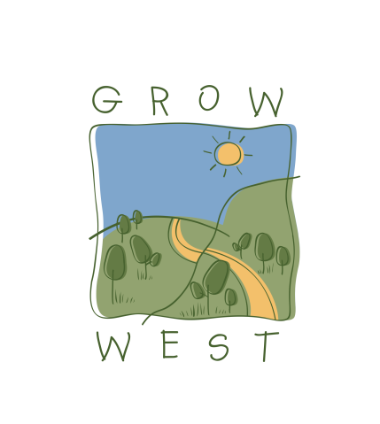
Snapshot
2005-06

On-ground works
- 200 ha of commercial tree Plantations through the National Landcare Program (NLP)
- 170ha Commonwealth Games Carbon Neutral biodiversity plantings
- 24ha of Biodiversity plantings through Natural Heritage Trust Program
- 10ha direct seeding of biodiversity species through the eTree initiative
- 20ha of revegetation works on Western Hwy with Vic Roads through eTree initiative
- 20 ha* of native saltbush/native grasses for production through the NLP
- 4ha of revegetation sponsored by Medibank Private
- 50ha* of revegetation works, 5km of River works and 800 ha of erodible soils managed through the National Landcare Program in conjunction with the Comaidai, Rowsley Valley and Pentland Hills Landcare groups project.

Community involvement:
- Medibank Planting Sunday 31st July – 50 staff and families
- Medibank Planting Wednesday 24th August
- Commonwealth Games Community Planting Day Sunday 14th August
- 3 Serrated Tussock forums
- Caulfield Grammar School Tour August 17th
- Melbourne Uni Landscape Architect School Research Visit 22nd August
- International Forestry Students Symposium Tour August
- Green Living Expo at Moorabool Shire – World Environment Day

