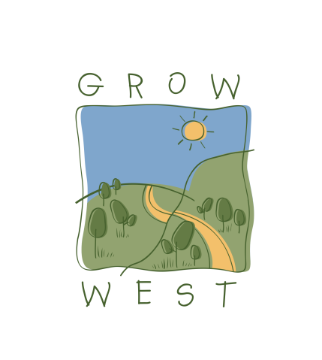
Snapshot
2004-05

On-ground works:
- 76ha Biodiversity planting’s through Natural Heritage Trust Program
- 25ha Direct seeding through eTree initiative
- 3.5ha Biodiversity planting sponsored by Medibank Private – 2 staff planting days
- 68ha of remnant vegetation protected with a Trust for Nature Covenant under the Envirofund Scheme (inc. 3km fencing) (Friends of Werribee Gorge and Long Forest Mallee)
- Purchase of community planting tools through ABN AMRO/AGL Staff Contribution
- 20ha Increasing production on farms using native species through National Landcare Program
- 4 properties undertaken a covenant or section 173 agreement
- Total 13 Landholders involved in projects located in the core Grow West area

Community involvement:
- 6 Grow West Workshops: over 40 people attended in 2004
- Planning the Plantings: 130 landholders have participated in aerial interpretation resulting in over 2,300ha identified for landscape change in the Grow West area.
- Medibank Private Staff: 2 staff planting days, over 40 staff participated
- Community Planting Day with Friends Group: 1 community planting day with 25 volunteers attending.
- Coimadai, Darley & Pentlands Primary School Tour: National Water Week with 175 students attending
- Melbourne University: Landscape Architecture Students completed a landscape study on Pentland Hills
- Over 75 participants in the community consultation meetings
- Continual liaison with local landcare groups
- World Environment Day Expo – Moorabool Shire Council

